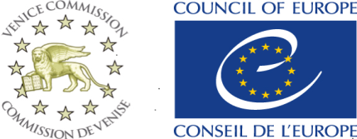
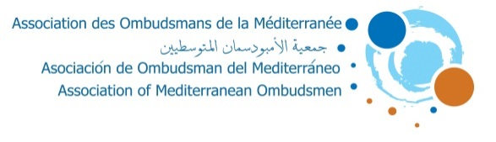

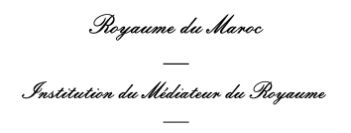

10th TRAINING SESSION OF COLLABORATORS OF THE OMBUDSMEN MEMBERS OF THE AOM
November 26th-27th 2019, Rabat
“The Own Initiative”

Draft PROGRAM
Tuesday 26 November 2019
08h15: Participants pick up from the hotel to the training venue (the institution main office)
Opening Ceremony
9h30-10h00: Opening speech of the President at the Mr. Mohamed Benalilou, Mediator of the Kingdom of Morocco
10h00-10h15: Speech of Ms. Caroline MARTIN, Legal Officer, Venice commission Council of Europe;
10h15-10h30: Presentation of the general framework by the Coordinator of the session, Mrs Fatima Kerrich, Head of Communication, Cooperation and Training Division at the Mediator’s Institution of the Kingdom of Morocco
10h30-11h00: Coffee break
11h00-11h30:
Module 1:
Own Initiative: Definition of legal foundations (introduction to the theme)
Experts:
-Mr Mohamed Benyahya, Advisor at the Mediator’s Institution of the Kingdom of Morocco
11h30-12h00: Presentation of experiences relevant to the topic and discussion
12h00-12h30:
Module 2:
Own Initiative: Procedures and steps for implementation
Experts:
-Mr Joaquim Pedro Cardoso da Costa, Deputy Ombudsman, Provedor de Justiça, Portugal
12h30-13h00: Presentation of experiences of institutions working in such field
Case study and discussion
13h00-13h30
Module 3:
Own Initiative as a tool to improve public services
Experts:
- ……………………………………………………………………………………….
13h30-14h00: case study and best practices’ highlight
14h00-15h30: Lunch
15h45: Sightseeing

Wednesday 27 November 2019

8h15: Participants pick up from the hotel to the training venue (the institution main office)
09h00-09h30:
Module 4:
Own Initiative: Strengths and constraints
Experts:
-Mr. Hassan S. A. HELASA, Field Researcher, Palestine
09h30-10h00: Presentation of experiences relevant to the topic
10h00-10h30:
Module 5:
Presentation of a successful practical case and a case of failure
Experts:
-Mr Jurgen CASSAR, Head of Communicationsand Research, Office of the Parliamentary Ombudsman, MALTA;
-Mrs Najoua ACHERGUI, Head of Complaints Analysis and Follow up, Institution of the Mediator of the Kingdom of Morocco
10h30-11h00: Presentation of experiences relevant to the topic
11h00-12h00: Coffee break
Closing session

12h00-13h00:
Presentation of the Summary Report
Closing speech of the Mediator of the Kingdom of Morocco
Certificates handing out.

13:30-15:00: Lunch
15:15: Sightseeing

