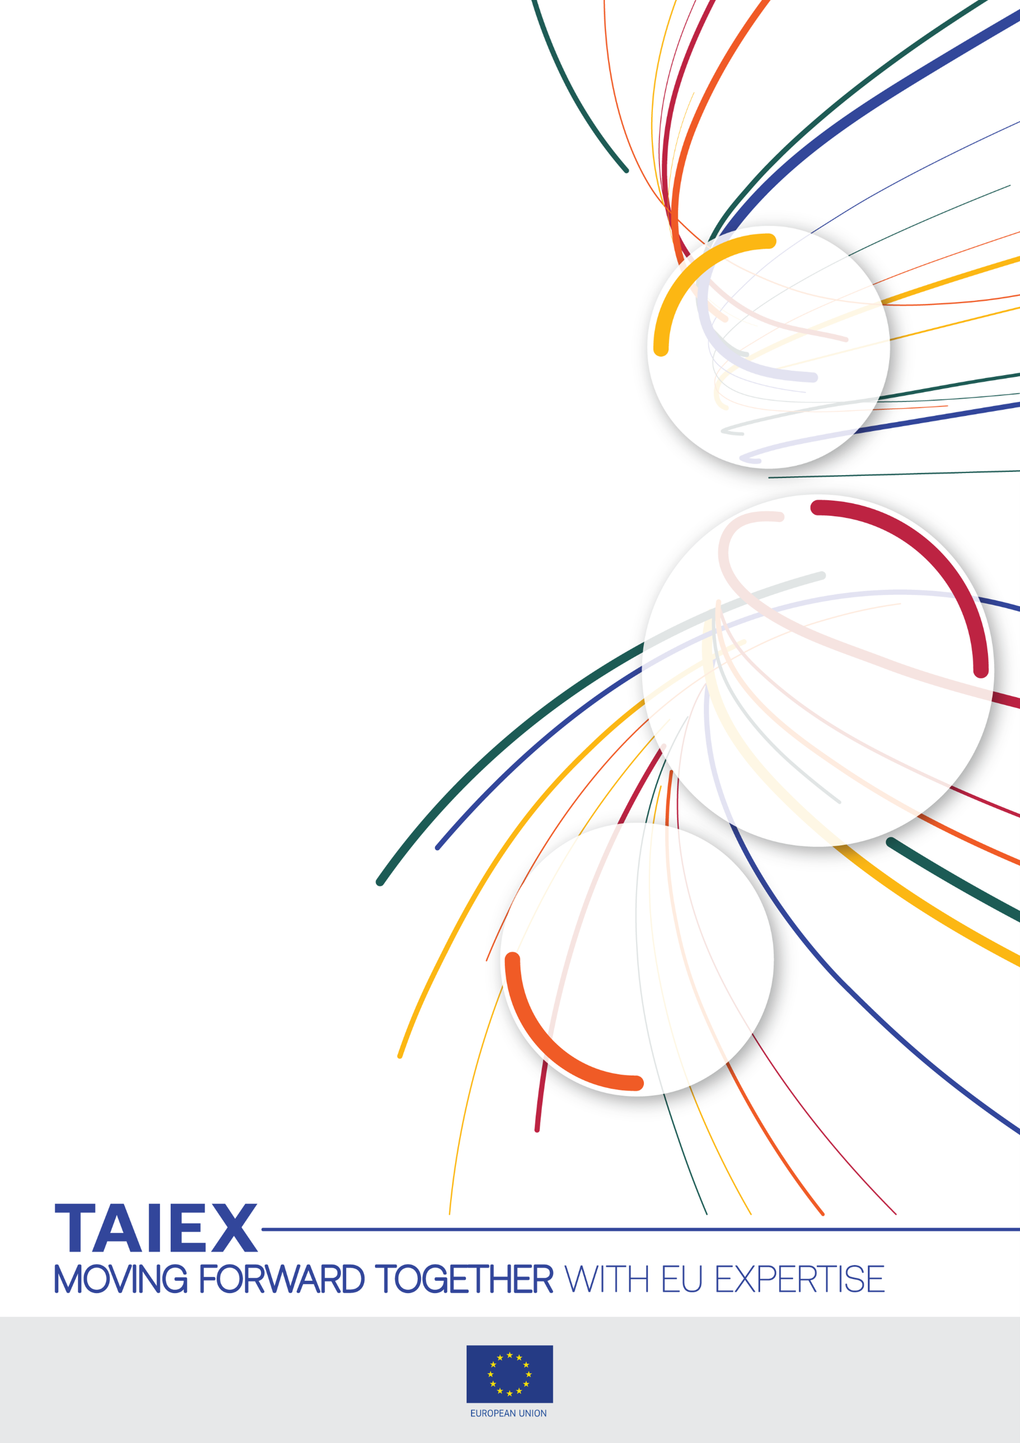

TAIEX INTPA SV on the right to information and administrative justice - Support to the Kenyan Ombudsman's Office
Organised in co-operation with
EU Delegation to Kenya, Commission on Administrative Justice, the Portuguese Ombudsperson’s Office, the Supreme Administrative Court, the Commission for Access to Administrative Documents and the General Prosecutor’s Office

24 - 26 February 2025
Venue:
Palácio Vilalva, Lisbon
Beneficiary:
Commission on Administrative Justice, Kenya

TAIEX Case ID INTPA IND/STUD 90037

Aim of the Study Visit:
This study visit, as last part of a series of exchanges, aims to enhance the capacities and skills of the CAJ investigation department in the areas of administrative justice and access to information.

Participants:
- Mr Charles Njagua Kanyi, Commissiner in charge of Complaints,investigations and Legal Services
- Ms Dorothy Kimengech, Vice Chairperson of the Commission and the Commissioner In Charge of Access to information
- Ms Florence Mumbi Kiawa, Director, Complaints,Investigations and Legal Services
- Ms Morine Akinyi, Assistant Director Investigations
- Mr Peter Korir, Senior Investigations officer
Speakers:

- Ms. Maria Lúcia Amaral, Ombudsperson of Portugal
- Ms. Estrela Chaby, Deputy Ombudsperson

- Mr. Ravi Afonso Pereira, Deputy Ombudsperson

- Mr. Miguel Feldmann, Head of the National Preventive Mechanism

- Mr. Duarte Geraldes, National Preventive Mechanism
- Ms. Sofia Duarte, Adviser of the Ombudsperson responsible for the Office of Law and International Relations
- Ms. Cristina Sá Costa, Office of Law and International Relations
- Ms. Teresa Bessa, Head of Unit B Labour and Social Rights

- Mr. Ricardo Neves, Adviser of the Ombudsperson
- Mr. João Portugal, Head of Triage Unit
- Ms. Catarina Ventura, Head of Unit A - Rights, Freedoms and Guarantees

- Ms. Erica Silva, Unit A - Rights, Freedoms and Guarantees
- Mr. Pedro Marchão Marques, Justice of the Portuguese Supreme Administrative Court
- Mr. António Mendes Oliveira, Head of Cabinet of the President of the Portuguese Supreme Administrative Court
- Ms. Graça Canto Moniz, Member of the Commission for Access to Administrative Documents
- Mr Tiago Fidalgo Freitas, Member of the Commission for Access to Administrative Documents
- Ms Joana Gomes Ferreira, Deputy Prosecutor General, Director of the International Cooperation Department
- Mr. André Folque, deputy Prosecutor General, Member of the Consultative Council of the Prosecutor General’s Office
- Ms Raquel Mota, Public Prosecutor, General Prosecutor’s Office
- Mr Emílio Sampaio Correia, Deputy Prosecutor General at the Supreme Administrative Court
- Mr. Fernando Gomes, Deputy Prosecutor General, Deputy Prosecutor General at the Supreme Administrative Court

Data Protection: Personal data contained in this document is processed in accordance with the privacy statement of the TAIEX instrument in compliance with Regulation (EU) 2018/1725. The chairperson should inform all persons attending the event that photographs/pictures should only be taken during a set period of time to allow for persons who do not agree to have their photographs taken to leave the room, unless all of the participants have provided their express consent to having their photograph taken.
See https://ec.europa.eu/neighbourhood-enlargement/sites/near/files/taiex_privacy_statement_online.pdf

Day 1: Monday 24 February 2025
Chair: Ms. Maria Lúcia Amaral, Ombudsperson of Portugal
Local time  10:00 – 10:15 | Arrival at the Portuguese Ombudsperson’s Office
10:15 – 10:30 | Welcome and introduction:  Ms. Maria Lúcia Amaral, Ombudsperson of Portugal
10:30 – 12:30 | Multidimensional mandate and framework of action  Speakers: Mr. Ravi Afonso Pereira, Deputy Ombudsperson  Mr. Miguel Feldmann, Head of the National Preventive Mechanism  Mr. Duarte Geraldes, National Preventive Mechanism  Ms. Cristina Sá Costa, Office of Law and International Relations
12:30 – 14:30 | Lunch break  Offered by the Portuguese Ombudsperson’s Office
14:30 – 16:30 | Instruments of intervention and cooperation with the public authorities  Speaker: Ms. Estrela Chaby, Deputy Ombudsperson  Ms. Teresa Bessa, Head of Unit B Labour and Social Rights  Mr. Ricardo Neves, Adviser of the Ombudsperson
16:30 – 17:00 | AOB and wrap up of day 1

Day 2: Tuesday 25 February 2025
Chair: Mr / Ms First name Family name, position, institution
Local time 09:30 – 09:45 | Arrival at the Portuguese Ombudsperson’s Office
9:45 – 11:15 | Complaints handling  Speaker: Mr. João Portugal, Head of Triage Unit
11:15 – 11:30 | Break
11:30 – 1215 | Mediation, recommendations and follow-up  Speakers: Ms. Catarina Ventura, Head of Unit A - Rights, Freedoms and Guarantees  Ms. Erica Silva, Unit A - Rights, Freedoms and Guarantees
12:15 – 12:30 | Brief wrap-up and conclusion  Speaker: Ms. Sofia Duarte, Adviser of the Ombudsperson responsible for the Office of Law and International Relations
12:30 – 14:20 | Lunch Break
14:20 – 14:30 | Arrival at the Portuguese Supreme Administrative Court
14:30 – 15:45 | Portuguese Administrative Justice System  - Administrative Justice and Access to Public Information  - Case law regarding Access to Public Information  - Q & A  Speaker: Mr. Pedro Marchão Marques, Justice of the Portuguese Supreme Administrative Court  Mr. António Mendes Oliveira, Head of Cabinet of the President of the Portuguese Supreme Administrative Court
15:45 – 16:00 | Guided tour of the Portuguese Supreme Administrative Court
16:00 – 16:15 | AOB and wrap up of day 2

Day 3: Wednesday 26 February 2025
Chairs: Ms Joana Gomes Ferreira, deputy Prosecutor General, Director of the International Cooperation Department
Mr. André Folque, deputy Prosecutor General, Member of the Consultative Council of the Prosecutor General’s Office
Local time  9:00-9:15 – | Arrival at the General Prosecutor's Office
9:15 – 09:30 | Introduction to the Portuguese Prosecution Service  Speaker: Ms Joana Ferreira, deputy Prosecutor General
09:30 – 10:30 | The High Council of the Public Prosecution Service  Speaker: Ms Raquel Mota, Public Prosecutor
10:30 – 10:45 | The Consultative Council of the General Prosecutor’s Office  Speaker: Mr. André Folque, deputy Prosecutor General, member of the Consultative Council
10:45-11:15 | Break
11:15-12:00 | The role of the Prosecution Service the Portuguese Administrative Justice System  Speaker: Mr Emílio Sampaio Correia, Deputy Prosecutor General at the Supreme Administrative Court;  Speaker: Mr. Fernando Gomes, Deputy Prosecutor General, Deputy Prosecutor General at the Supreme Administrative Court
12:00-12:15 | Wrap up of the morning session
12:15 – 14:00 | Lunch break  Transfer to the Commission for Access to Administrative Documents
14:00 – 14:45 | The Commission for Access to Administrative Documents (CAAD)  - CAAD – brief overview  - Some statistical data  - Case study on Access to Public Information  Speaker: Ms. Graça Canto Moniz, Member of the Commission for Access to Administrative Documents
14:45 – 15:15 | Break
15:15 – 16:00 | Assessment of the Implementation of the Administrative Document Access Law in Portugal (2024)  - Goals / initial questions  - Applied model – the «Theory of change»  - Conclusions and recommendations  Speaker: Mr Tiago Fidalgo Freitas, Member of the Commission for Access to Administrative Documents
16:00 – 16:15 | AOB and wrap up of day 3


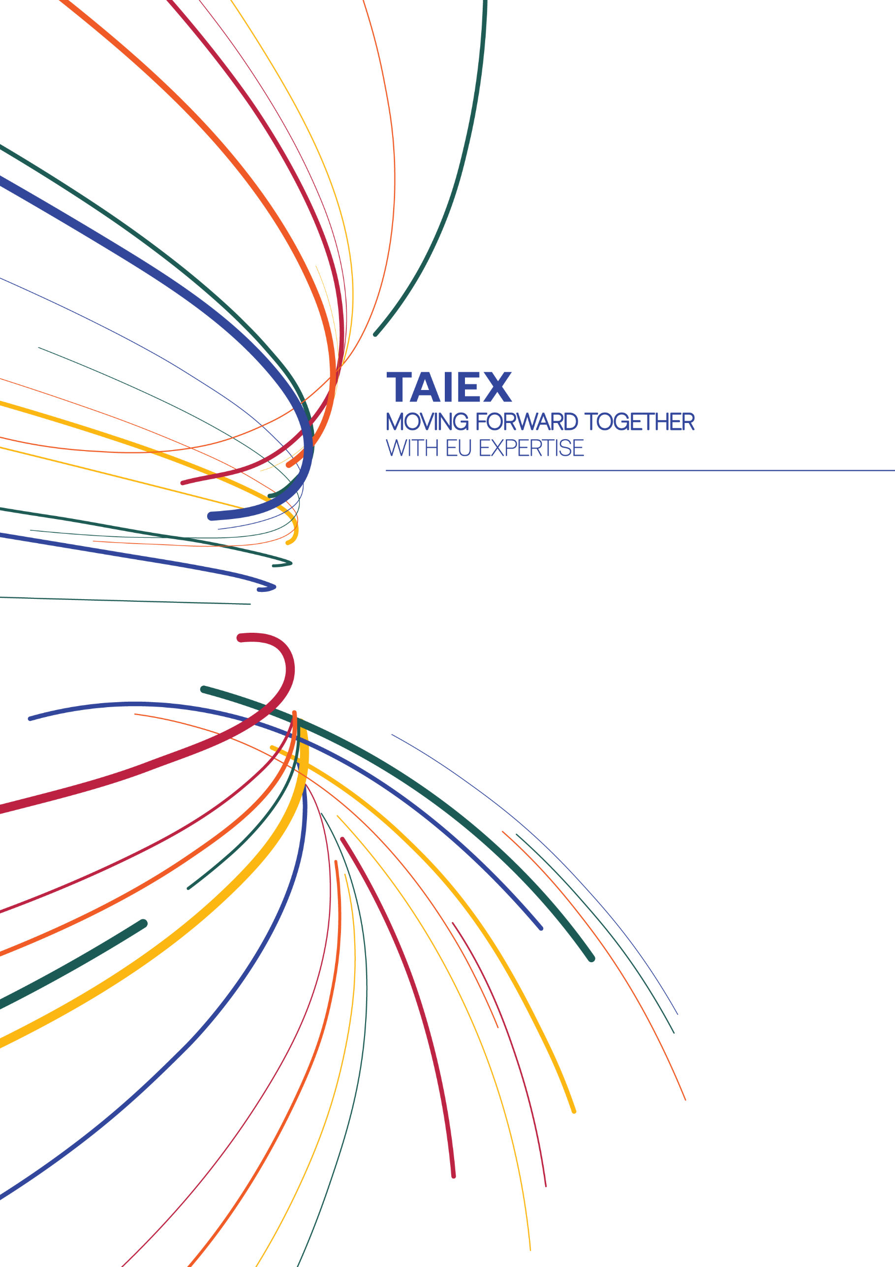


near-taiex@ec.europa.eu

ec.europa.eu/taiex
@eu_near #EUTaiex



facebook.com/EUNEAR

